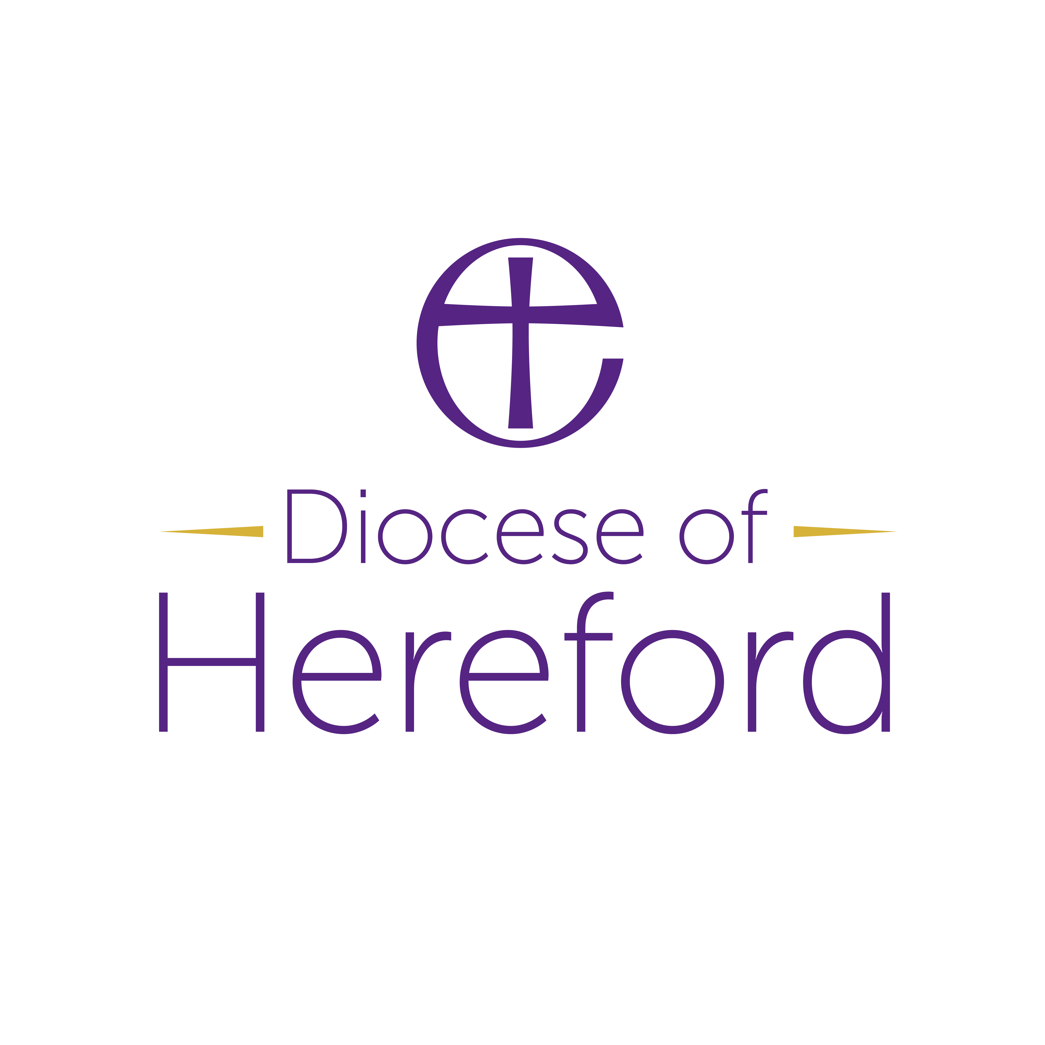
Mustard Seed - Small Projects Grant Application

Project title
Date
Amount requested (max £8k over 3years)
Total cost of project being funded

Short description of your project and what you will use the Total Return Mustard Seed Funding for.
Please explain how your project fits into your vision for mission in your area, and what do you hope to see at the end of the project.

Please email your completed application to David Morris david.morris@hereford.anglican.org
Your application will be considered by your Archdeacon, the Diocesan Secretary and must have the support of your Deanery Leadership Team (please include in your application).

DECISION: --

