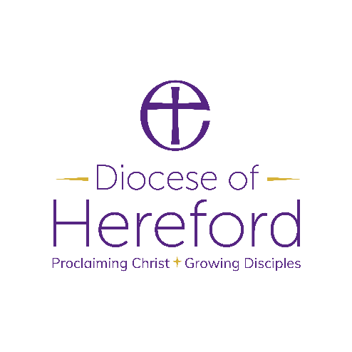

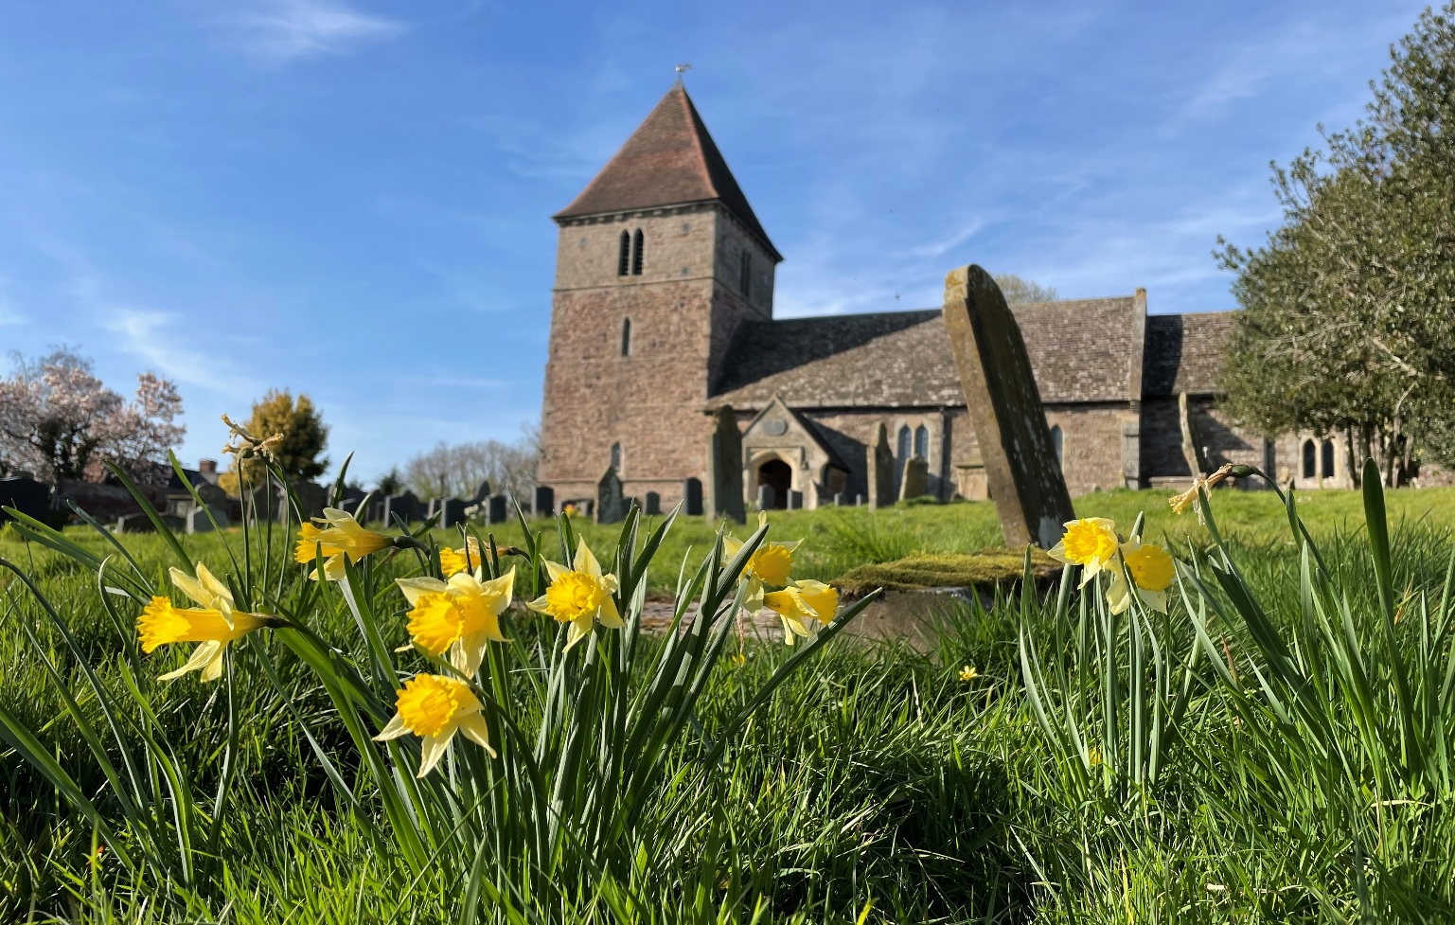
Prayer Diary
March – May 2026

 | www.hereford.anglican.org | 

Our 1350th Anniversary

In 2026 we are celebrating the 1350th anniversary of the founding of Hereford Diocese, in 676AD, and the people and places that make up this very special place, with a Year of Celebration.

Listings of Year of Celebration events and a selection of resources are on our website here: https://hereford.anglican.org/our-faith/1350/. In the meantime, here is a list of key dates for your diary:

Spiritual Question Time

This is a series of locally hosted events that will take place across the diocese. They provide an opportunity to ask questions about faith and explore a Christian perspective on contemporary issues. If you would like to host an event in your parish, benefice or deanery, please get in touch with our comms team. Venues and panellists to be confirmed unless stated.

Monday 20 April 2026 - Abbeydore Deanery, venue TBC
Tuesday 12 May 2026 - Hereford Cathedral; Bishop Richard and Chancellor James Pacey
Wednesday 15 July 2026 - The Garway Moon Inn, Garway, Herefordshire with Bishop
Richard and Dean Sarah
Tuesday 22 September 2026 - Bridgnorth with Bishop Richard and Dean Sarah, venue TBC
Tuesday 10 November 2026 - with Bishop Richard and Chancellor James Pacey, venue TBC

Celebration of Mission & Ministry

Thursday 5 Mar 2026 10:30 am Hereford Cathedral - Celebration of Church School Partnership, led by Bishop Richard and Mark Harrington on YouTube (Invitation only)
Saturday 20 June at 2:00 pm – Confirmation Service in Hereford Archdeaconry at Hereford Cathedral, followed by a celebration at The Palace hosted by Bishop Richard
Saturday 10 Oct 2026
- 10:30 am - Celebration of Lay Ministry, including Reader admissions at Ludlow St Laurence
- 2:30 pm - Confirmation Service in Ludlow Archdeaconry, followed by a celebration event hosted by Bishop Richard

Celebration Days | Pilgrimage

Sat 16 May 2026 – Leominster, honouring St Eadfrith; worship and communion led by Bishop Richard
Sat 19 Sep 2026 – Much Wenlock (Madely area), honouring St Milburga; worship and communion led by Bishop Richard
Sat 17 Oct 2026 – Golden Valley / Madley, honouring St Dyfrig; worship and communion led by Bishop Richard

The Deaneries
Hereford Archdeaconry | Ludlow Archdeaconry
- A. Abbeydore | - H. Clun
- B. Bromyard | - I. Condover
- C. Hereford City | - J. Ludlow
- D. Kington and Weobley | - K. Pontesbury
- E. Ledbury | - L. Severn Borders
- F. Leominster
- G. Ross and Archenfield
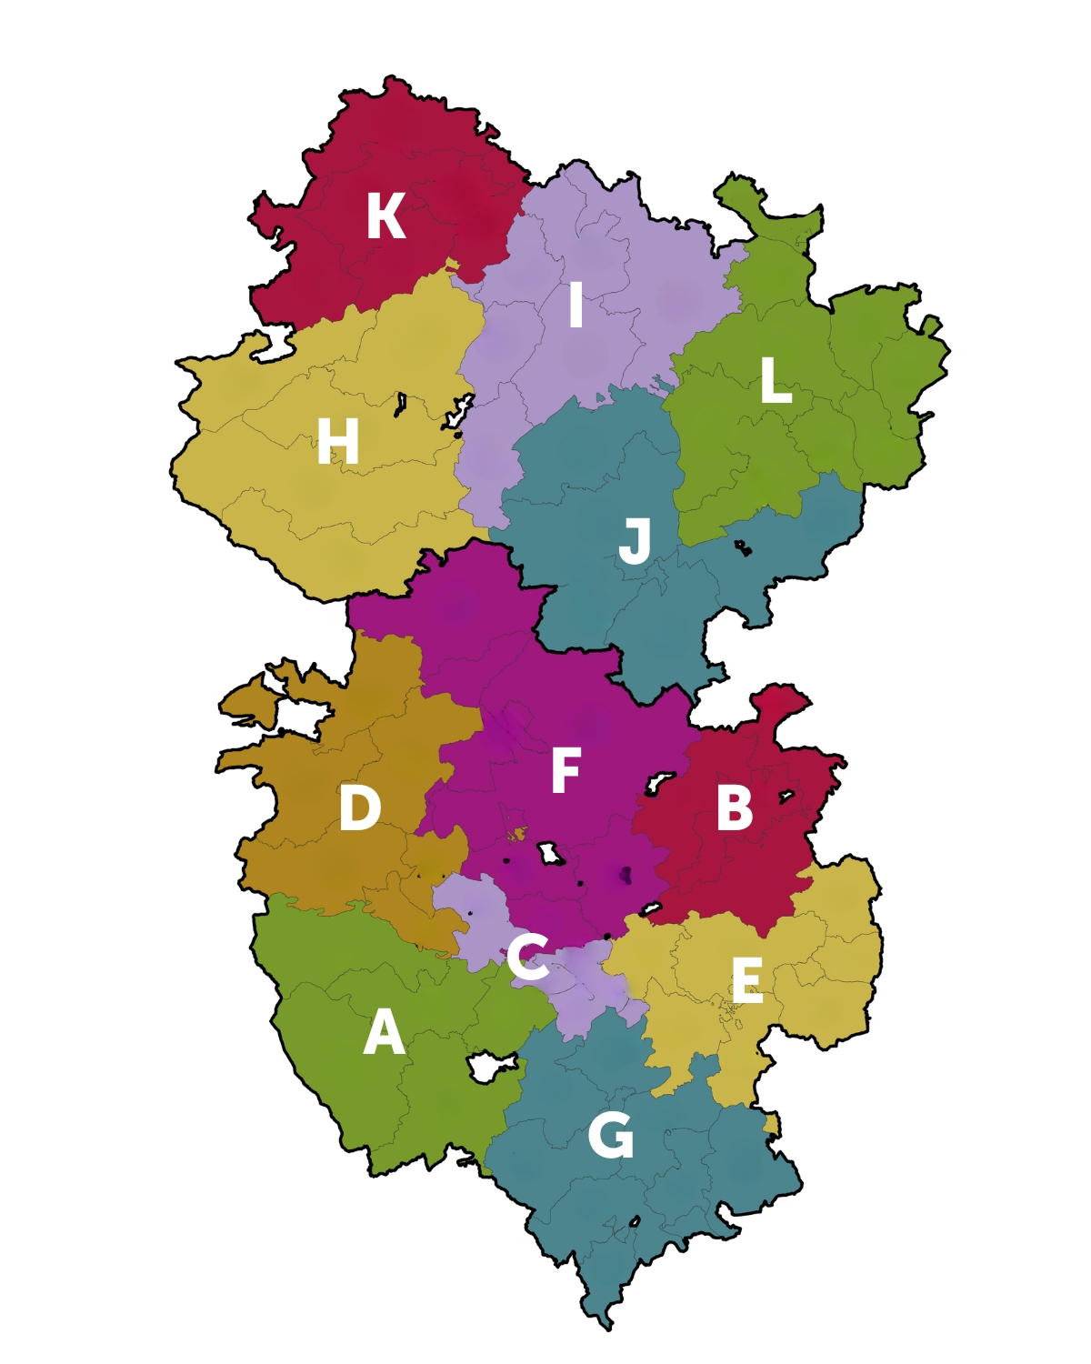

The Prayer Diary – March to May 2026
The main part of this Prayer Diary covers the second quarter of the Church Year, week by week, under the following headings:

- Anglican - Taken from the Anglican Cycle of Prayer and updated as fully and accurately as possible, so that we can pray with confidence with and for the Anglican Communion worldwide.

- Hereford – Each Benefice is prayed for twice a year, our diocesan leaders and all church schools and headteachers, and youth hubs once each year, interspersed with the wider needs of the diocese.

- Porvoo - This weekly bidding pairs the Lutheran churches of the Nordic and Baltic areas and the Anglican churches of the British Isles and of Spain and Portugal, which have signed the Porvoo Declaration recognising each other’s ministries. Also included is the Latvian Church, which has not yet taken a decision on signing the Declaration, and the Church of Denmark, which has not signed but wishes to develop links with the churches which have signed.

- The Wider View - Biddings and promptings for prayer relating to the wider world, the economy and global politics.

- Today – Details on what is happening in the life of the diocese to prompt your own intercessions, such as churchwarden visitations, General Synod meetings and ordinations.

- Prayer – The Anglican Collect for the Sunday prior.

If you would like to submit items for inclusion, ideas, or comments, please email the Bishop’s Chaplain at chaplain@hereford.anglican.org.

You can also view the Prayer Diary on our website under the section Our Faith > Spirituality and Discipleship > Prayer: https://www.hereford.anglican.org/prayer

Week commencing Sunday 1st March to Saturday 7th March
Sunday 1st March |  | Lent 2
Anglican | The Nippon Sei Ko Kai (the Anglican Church in Japan). The Most Revd David Eisho Uehara
Hereford | The Kington and Weobley Deanery: Rural Dean: Katie Smith
Porvoo | Church of England: Diocese of Canterbury - Archbishop Sarah Mullaly, Bishop Rose Hudson-Wilkin  Church of Ireland: Diocese of Down and Dromore, Bishop David McClay
The Wider View | God of peace and compassion, we thank you for the world you have given us and the privilege it is to be able to call on your name. As the church recognises the World Prayer Day (6th March), we pray that you would sow seeds of unity within the Church of England, and the Christian church all over the world, that we would more faithfully embody of the Gospel, and more would come to know your saving power, through Jesus Christ our Lord.
Collect | Almighty God,  by the prayer and discipline of Lent  may we enter into the mystery of Christ’s sufferings,  and by following in his Way  come to share in his glory;  through Jesus Christ our Lord. Amen

Monday 2nd March
Anglican | The Diocese of Toamasina – The Church of the Province of the Indian Ocean: The Rt Revd Jean Paul Solo
Hereford | EARDISLEY with BOLLINGHAM and WILLERSLEY, BRILLEY, MICHAELCHURCH, WHITNEY, WINFORTON, ALMELEY and KINNERSLEY: Marcus Small, and Assistant Katie Smith

Tuesday 3rd March
Anglican | The Diocese of Tohoku – The Nippon Sei Ko Kai (The Anglican Church in Japan): The Rt Revd Francis Kiyosumi Hasegawa
Hereford | KINGTON with HUNTINGTON, OLD RADNOR, KINNERTON and TITLEY: Sally Welch, Curate Phillippa Wright, and Assistant Paul Buckingham

Wednesday 4th March
Anglican | The Diocese of Tokyo – The Nippon Sei Ko Kai (The Anglican Church in Japan) : The Rt Revd Francis Xavier Hiroyuki Takahashi
Hereford | Today we pray for our farmers and their workers and families. As spring blossoms after a long and wet winter, that they would know your hand upon them, and you would protect the work of their hands, and give them tenacity in a changing environmental and climate landscape.

Thursday 5th March
Anglican | The Diocese of Toliara – The Church of the Province of the Indian Ocean : The Rt Revd Samitiana Jhonson Razafindralamb
Hereford | Eardisley CE Primary School - Headteacher Laurie Williams

Friday 6th March | World Prayer Day
Anglican | The Diocese of Tonj – Province of the Episcopal Church of South Sudan: The Rt Revd Peter Yuoi Gur
Hereford | The Bishop's Office staff: Ros, Gail and Jane
Today | The Hereford Passion at Hereford Cathedral
Saturday 7th March
Anglican | The Diocese of Torit – Province of the Episcopal Church of South Sudan; The Most Revd. Ogeno Opoka
Hereford | PEMBRIDGE with MOORCOURT, SHOBDON, STAUNTON-ON-ARROW, BYTON and LYONSHALL: Anna Branston
Today | The Hereford Passion at Hereford Cathedral

Week commencing Sunday 8th March
Sunday 8th March |  | Lent 3
Anglican | The Episcopal Church in Jerusalem & The Middle East: Archbishop The Most Revd Hosam Naou
Hereford | For all those exploring vocations in the Church of England, and those who support them.
Porvoo | Church of England: Diocese of Chelmsford, Bishop Guli Francis-Dehqani, Bishop Roger Morris, Bishop Lynne Cullens, Bishop Adam Atkinson  Church of Sweden: Diocese of Karlstad, Bishop Sören Dalevi
The Wider View | Almighty God,  as the world marks International Women’s Day we thank you for the leadership of women across the globe. We pray for women whom we know personally who are setting examples for those who will follow them into roles unimaginable 30 years ago.  As the nations gather at the United Nations Human Rights Council (23rd February–2nd April 2026), give wisdom to all leaders and delegates, that justice may be upheld, the oppressed defended,  and peace pursued among all peoples.  Strengthen all who strive for justice, and a fairer society, locally and across the world.
Collect | Eternal God,  give us insight  to discern your will for us,  to give up what harms us,  and to seek the perfection we are promised  in Jesus Christ our Lord. Amen

Monday 9th March
Anglican | The Diocese of Toronto – The Anglican Church of Canada: The Most Revd. Andrew Asbil
Hereford | PRESTEIGNE with DISCOED, KINSHAM, LINGEN & KNILL: Stephen Hollinghurst, and Assistant Debbie Venables

Tuesday 10th March
Anglican | The Diocese of Trichy-Tanjore – The Church of South India (United): The Rt Revd Dr S. Samuel Rajadurai

Wednesday 11th March
Anglican | The Diocese of Trinidad and Tobago – The Church in the Province of the West Indies; The Rt Revd Claude Berkley
Hereford | The Benefice of Weobley and Staunton (WEOBLEY, STAUNTON-ON-WYE, NORTON CANON, MONNINGTON, SARNESFIELD, BYFORD and LETTON): Philip Harvey

Thursday 12th March
Anglican | The Diocese of Truro – The Church of England: David Williams  Suffragan Bishop St Germans: vacant
Hereford | We pray today for clergy gathering for the Sacred Synod in Hereford. That ministers would be strengthened, encouraged and emboldened in prayer and ministry.
Today | Sacred Synod at the Bishop’s Palace for Licensed Clergy

Friday 13th March
Anglican | The Diocese of Tuam, Limerick and Killaloe – The Church of Ireland: The Rt Revd Michael Burrows
Hereford | Bosbury Church of England Primary School - Headteacher Ruth McManus
Saturday 14th March
Anglican | The Diocese of Twik East – Province of the Episcopal Church of South Sudan: The Rt Revd Jacob Deng Garang Akech
Hereford | COLWALL with UPPER COLWALL and CODDINGTON: Melanie Horton, and Curate Andrew Falconer

Week Commencing Sunday 15th March 2026
Sunday 15th March |  | Lent 4 | Mothering Sunday
Anglican | The Anglican Church of Kenya : Archbishop Jackson Ole Sapit
Hereford | The Mother’s Union and their work at home and abroad
Porvoo | Evangelical Lutheran Church of Latvia: Archbishop Rinalds Grants, Bishop Einārs Alpe, Bishop Hanss Martins Jensons, Bishop Uldis Gailitis  Church of England: Diocese of Lichfield, Bishop Michael Ipgrave, Bishop Timothy Wambunya, Bishop Sarah Bullock, Bishop Matthew Parker, Bishop Paul Thomas  Church in Wales: Diocese of St David’s, Bishop Dorrien Davies
The Wider View | Loving God, on Mothering Sunday (15th March)  we give thanks for those who nurture with compassion,  and we pray for all families  We remember particularly those those who carry sorrow or longing for whom today brings pain: for those who long to be parents, and those for whom that longing has been unfulfilled. For those who have lost their children, and those who have lost parents, through death, action, or poor decisions.  We thank you that you are our loving, unfailing parent, and for the gift of your Church as a community for those who have nowhere else to belong.
Collect | God of love,  passionate and strong,  tender and careful:  watch over us and hold us  all the days of our life;  through Jesus Christ our Lord.  Amen

Monday 16th March
Anglican | The Anglican Church of Kenya : The Rt Revd Chjioke Augustine Aneke
Hereford | Colwall CE Primary School - Headteacher Gina Harrison

Tuesday 17th March
Anglican | The Diocese of Northern Uganda – The Church of the Province of Uganda: The Rt Revd Johnson Gakumba
Hereford | FOWNHOPE with MORDIFORD, BROCKHAMPTON and WOOLHOPE: Chris Moore, and Curate Owen Pembury

Wednesday 18th March
Anglican | The Diocese of Ughelli – The Church of Nigeria (Anglican Communion): The Rt Revd Cyril Odutemu
Hereford | We pray for affordable housing for families, for sustainable home building, for new communities to thrive and for adequate provision of health, education and essential services as our communities grow.
Thursday 19th March | Joseph of Nazareth
Anglican | The Diocese of Ukwa – The Church of Nigeria (Anglican Communion): The Rt Revd Samuel Kelechi Eze
Hereford | As we remember St Joseph, we pray for those who work to support their families. Give them tenacity, courage and integrity in their labours, and satisfaction in their work.

Friday 20th March
Anglican | The Diocese of Umuahia – The Church of Nigeria (Anglican Communion) : Most Revd. Ikechi Nwachukwu Nwosu
Hereford | CRADLEY with MATHON and STORRIDGE: for their future minister, Rosie Roberts who begins in the summer.
Saturday 21st March
Anglican | Te Pihopatanga o Te Upoko o Te Ika – The Anglican Church in Aotearoa, New Zealand and Polynesia: The Rt Revd Waitohiariki Quayle
Hereford | We pray for those farmers and workers preparing or amid lambing season. For safety of ewes, lambs and those who care for them.

Week commencing Sunday 22nd March 2026
Sunday 22nd March |  | Lent 5 | Passiontide begins
Anglican | The Anglican Church of Korea : Primate: Most Revd Onesimus Dongsin Park
Hereford | The Ledbury Deanery: Rural Dean: Chris Moore, Lay Chair: Kevin Hewison
Porvoo | Church of Sweden: Diocese of Lund, Bishop Johan Tyrberg  Church of Ireland: Diocese of Cashel, Ossory and Ferns, Bishop Adrian Wilkinson  Church of England: Diocese of Ely, vacancy – bishop of Ely, Bishop Dagmar Winter (acting bishop)
The Wider View | God of promise. We stand on the threshold of Holy Week, between what has been and what is to come.  As we wait, we hold before you a world longing for peace: the people of Ukraine, living with the weight of ongoing war; those suffering amid violence and instability in Gaza and Israel, Sudan, Yemen, and Myanmar;  and all places where conflict, fear, and loss feel unending.  Teach us to wait with faith when answers seem slow to come,  to trust your work even when we cannot see it, and to carry hope quietly in our hearts.  Prepare us to walk with Jesus through the cross and toward resurrection,  bearing your peace into a wounded world.
Collect | Gracious Father,  you gave up your Son  out of love for the world:  lead us to ponder the mysteries of his passion,  that we may know eternal peace  through the shedding of our Saviour’s blood,  Jesus Christ our Lord. Amen
Today | City Praise (Ecumenical Service) at Hereford Cathedral

Monday 23rd March
Anglican | The Diocese of Uruguay – The Anglican Church of South America: The Rt Revd Daniel Genovesi (interim Bishop)
Hereford | LEDBURY with EASTNOR: in vacancy, Assistant Tony Hodder

Tuesday 24th March
Anglican | The Diocese of Utah – The Episcopal Church (USA): Rt Revd Phyllis Spiegel
Hereford | The Cider Churches (AYLTON, LITTLE MARCLE, MUCH MARCLE with YATTON, PIXLEY, PUTLEY and WELLINGTON HEATH): Val Tait, and Associate William Simmonds
Today | The Bishop’s Staff Meeting happens today
Wednesday 25th March | The Annunciation
Anglican | The Diocese of Uyo – The Church of Nigeria (Anglican Communion): Rt Revd Owen Ukafia
Hereford | For those who are isolated, especially in rural communities. May we be attentive to the needs of those around us.
Today | Installation of Archbishop Sarah as Archbishop of Canterbury
Thursday 26th March
Anglican | The Diocese of Valparaiso – Iglesia Anglicana de Chile: Vacant
Hereford | Cradley CE Primary School - Headteacher Donna Jones
Friday 27th March
Anglican | The Diocese of Vanuatu – The Anglican Church of Melanesia: The Rt Revd James Tama
Hereford | Mordiford CE Primary School - Headteacher Sue Warmington
Today | Bishop’s Council meet tonight
Saturday 28th March
Anglican | The Diocese of Vellore – The Church of South India (United): The Rt Revd Sharma Nithiyanandham
Hereford | LUGWARDINE with BARTESTREE, WESTON BEGGARD, DORMINGTON, WESTHIDE and WITHINGTON (The Bartestree Cross Group): Tiffany Jackson, and Curate Suanna Rosier

Week commencing Sunday 29th March
Sunday 29th March |  | Palm Sunday
Anglican | The Anglican Church of Melanesia : Archbishop The Most Revd. Leonard Dawea
Hereford | All readers of the Diocese and The Warden of Readers: Mark Godson
Porvoo | Church of Ireland: Diocese of Armagh, Archbishop John McDowell  Evangelical Lutheran Church in Denmark: Diocese of Funen, Bishop Mads Davidsen  Church of England: Diocese of Sodor and Man, Bishop Tricia Hillas
The Wider View | Lord Jesus, as we walk through Holy Week, draw us into the mystery of your saving love, and deepen our faith at the foot of the cross.  On Good Friday give your mercy to a suffering world and bring comfort to all who carry sorrow and pain.  And as we rejoice on Easter Day, renew us with the power of your resurrection, that we may live as people of hope; for you live and reign, now and for ever.
Collect | True and humble king,  hailed by the crowd as Messiah:  grant us the faith to know you and love you,  that we may be found beside you  on the way of the cross,  which is the path of glory.  Amen

Monday 30th March
Anglican | The Diocese of Venezuela – The Episcopal Church : The Rt Revd Orlando Guerrero Torres
Hereford | Eastnor Parochial CE Primary School - Headteacher Nikki Driscoll

Tuesday 31st March
Anglican | The Diocese of Vermont – The Episcopal Church : The Rt Revd Shannon MacVean-Brown
Hereford | Much Marcle CE Primary School - Headteacher Laura Davies

Wednesday 1st April
Anglican | The Diocese of Victoria Nyanza – The Anglican Church of Tanzania : Vacant
Hereford | We pray for all priest and deacons who are renewing their ordination vows today. Equip and inspire them in their life of witness and worship.
Today | Chrism Mass service at Hereford Cathedral

Thursday 2nd April | MAUNDY THURSDAY
Anglican | The Diocese of Virgin Islands – The Episcopal Church : The Rt Revd Ambrose Gumbs
Hereford | As altars are stripped across the diocese tonight as we remember the sense of loss, hopelessness and fear felt by the disciples as Jesus was betrayed. We pray today for all who feel a sense of hopelessness in our community, that God would meet them with his peace and renew their hope and purpose.

Friday 3rd April | GOOD FRIDAY
Anglican | The Diocese of Virginia – The Episcopal Church : The Rt Revd Mark Stevenson
Hereford | In bare churches across the country, we pray today for all those who have lost homes, family and friends in war, fire, flood or famine. We pray particularly for those affected by endless flooding this winter, for farmer whose fields are stripped of crops, for homes now stripped bare for repair, and for all who carry a sense of loss today.
Saturday 4th April | HOLY SATURDAY
Anglican | The Diocese of Southern Virginia – The Episcopal Church : The Rt Revd Susan Haynes
Hereford | On this holy day, when Jesus has died but not yet been resurrected, we pray for all those in our Diocese who live with uncertainty and in places of fear. May God bring them hope as churches across the world symbolically bring light into dark places as your resurrection is remembered and celebrated.

Week commencing Sunday 5th April
Sunday 5th April |  | Easter Day
Anglican | La Iglesia Anglicana de Mexico : Primate: Most Revd. Enrique Treviño Cruz
Hereford | Today we pray for all those in our communities who feel unwelcome.
Porvoo | Church of Sweden: Diocese of Uppsala, Archbishop Martin Modéus, Bishop Karin Johannesson  Church in Wales: Diocese of Llandaff, Bishop Mary Stallard
The Wider View | Almighty God, as the world observes World Health Day, we pray that you would bring healing to the sick, and strength to those who care for others, and justice in the provision of healthcare for all.  We pray for those gathered at the Forum for the Future of Agriculture in Brussels on April 14th that leaders and communities may work together for sustainable livelihoods, food security, and hope in rural places.  And as nations prepare for decisions of global economic influence, grant wisdom and compassion to all who shape policy, that the needs of the poor may not be forgotten and your creation may be cared for with faithfulness.
Collect | God of glory,  by the raising of your Son  you have broken the chains of death and hell:  fill your Church with faith and hope;  for a new day has dawned  and the way to life stands open  in our Saviour Jesus Christ.  Amen

Monday 6th April
Anglican | The Diocese of Southwestern Virginia – The Episcopal Church : Vacant
Hereford | The Hop Churches (ASHPERTON, BOSBURY, CANON FROME, MUNSLEY, STOKE EDITH, STRETTON GRANDISON with ASPERTON, TARRINGTON, YARKHILL): Mandy Williams, and Curate Linde Melhuish

Tuesday 7th April
Anglican | The Diocese of West Virginia – The Episcopal Church : The Rt Revd Matthew Cowden
Hereford | Fownhope St Mary's CE Primary School - Headteacher Tim Milne

Wednesday 8th April
Anglican | The Diocese of Wad Medani – Province of the Episcopal Church of Sudan: The Rt Revd Saman Farajalla Mahdi
Hereford | Burghill Group of Parishes (BURGHILL, MORETON-ON-LUGG, PIPE-CUM-LYDE, STRETTON SUGWAS): Phill Brown

Thursday 9th April
Anglican | The Diocese of Waiapu – The Anglican Church in Aotearoa, New Zealand and Polynesia : The Rt Revd Andrew Hodge
Hereford | Leintwardine Endowed CE Primary School - Headteacher Nicola Gorry

Friday 10th April
Anglican | The Diocese of Waikato and Taranaki – The Anglican Church in Aotearoa, New Zealand and Polynesia : The Rt Revd Philip Richardson
Hereford | KINGSLAND with EARDISLAND, AYMESTREY and LEINTHALL EARLES: in vacancy, Curate Rosie Roberts
Saturday 11th April
Anglican | Te Pihopatanga o Te Waipounamu – The Anglican Church in Aotearoa, New Zealand and Polynesia : Vacant
Hereford | Bodenham St Michaels' Church of England Primary School – Executive Headteacher Michelle Lewis

Week commencing Sunday 12th April
Sunday 12th April |  | Easter 2
Anglican | Igreja Anglicana de Mocambique e Angola: Presiding Bishop, The Most Revd. Vincente Msosa
Hereford | The Archdeacon of Hereford: The Venerable Derek Chedzey
Porvoo | Church of England: Diocese of Derby, Bishop Libby Lane, Bishop Malcolm Macnaughton  Church of Ireland: Diocese of Clogher, Bishop Ian Ellis  Evangelical Lutheran Church in Denmark: Diocese of Aalborg, Bishop Thomas Reinholdt Rasmussen
The Wider View | God of righteousness, we pray for the nations and leaders gathered at the International Monetary Fund and World Bank Spring Meetings (13th–18th April 2026). Grant wisdom to those shaping the global economy, that decisions may be guided by justice, the burdens of poverty relieved, that the tenure of those using their influence for personal financial gain would cease, and the needs of the vulnerable placed first. May the resources of the earth be shared with fairness, that all people would live with dignity and hope.
Collect | Risen Christ,  for whom no door is locked, no entrance barred:  open the doors of our hearts,  that we may seek the good of others  and walk the joyful road of sacrifice and peace,  to the praise of God the Father. Amen

Monday 13th April
Anglican | The Diocese of Wandi – Province of the Episcopal Church of South Sudan: The Rt Revd Yohanas Benjamin Dirar
Hereford | Canon Pyon CE Academy - Headteacher Kelly Carpenter

Tuesday 14th April
Anglican | The Diocese of Wangaratta – The Anglican Church of Australia: The Rt Revd Clarence Bester
Hereford | CANON PYON with KING'S PYON, BIRLEY and WELLINGTON: Anne Price

Wednesday 15th April
Anglican | The Diocese of Wanglei – Province of the Episcopal Church of South Sudan: The Rt Revd Zechariah Mayok Biar

Thursday 16th April
Anglican | The Diocese of Wanyjok – Province of the Episcopal Church of South Sudan: The Rt Revd Mamer Manot
Hereford | Stretton Sugwas CE Academy – Executive Headteacher Ben Caldicott
Today | DBF Synod

Friday 17th April
Anglican | The Diocese of Warri – The Church of Nigeria (Anglican Communion): The Rt Revd Christian Esezi Ide
Hereford | LEOMINSTER, Team Ministry (BOCKLETON, BRIMFIELD, CROFT with YARPOLE and LUCTON, DILWYN and STRETFORD, DOCKLOW, EYE, EYTON, HATFIELD, HOPE-UNDER-DINMORE, HUMBER, IVINGTON, KIMBOLTON with HAMNISH, LEOMINSTER, LEYSTERS, MIDDLETON-ON-THE-HILL, MONKLAND, ORLETON, PUDLESTON-CUM-WHYLE, STOKE PRIOR and FORD): Guy Cole, and Team Vicars Mark Long and Matthew Burns, and Curates Fiona Honeysett and William Talbot-Ponsonby
Saturday 18th April
Anglican | The Diocese of Washington – The Episcopal Church: The Rt Revd Mariann Edgar Budde
Hereford | Dilwyn St Mary's CE Primary School - Principal Peter Kyles

Week commencing Sunday 19th April
Sunday 19th April |  | Easter 3
Anglican | The Church of the Province of Myanmar (Burma): Archbishop, The Most Revd. Stephen Than Myint Oo
Hereford | The Leominster Deanery: Rural Dean: Mark Long, Lay Chair: Lydia Davies
Porvoo | Church of England: Diocese of Blackburn, Bishop Philip North, Bishop Jill Duff, Bishop Joseph Kennedy  Scottish Episcopal Church: Diocese of Brechin, Bishop Andrew Swift  The Lutheran Church in Great Britain: Bishop Paulina Hlawiczka-Trotman
The Wider View | Almighty God, who called Saint Mark the Evangelist to proclaim the good news of Jesus Christ, grant that we too may be faithful in witness,  bold in compassion, and steadfast in hope. As International Volunteer Week begins, we give thanks for those in our churches who give of their time and talents to serve both church and community.  As social media floods us with images of children dressing up for World Book Day, renew our joy in simple things and give us childlike delight at the world around us.
Prayer | Risen Christ,  you filled your disciples with boldness and fresh hope:  strengthen us to proclaim your risen life  and fill us with your peace,  to the glory of God the Father. Amen

Monday 20th April
Anglican | The Diocese of Wau – Province of the Episcopal Church of South Sudan: The Most Revd. Deng Boi
Hereford | Orleton CE Primary School - Executive Head Adam Breakwell
Today | Spiritual Question Time: The Bishop and James

Tuesday 21st April
Anglican | The Diocese of Wellington – The Anglican Church in Aotearoa, New Zealand and Polynesia: The Most Revd. Justin Duckworth
Hereford | Ivington CE Primary School - Headteacher Melanie Smith

Wednesday 22nd April
Anglican | The Diocese of Wernyol – Province of the Episcopal Church of South Sudan: The Rt Revd Gabriel Kuol Garang
Hereford | For committees preparing community events: for livestock festivals, summer fetes and for strengthening of community bonds through their endeavours.
Thursday 23rd April | George, martyr, Patron of England
Anglican | The Diocese of Wiawso – The Church of the Province of West Africa: The Rt Revd Kwame Kyem-Ampomah
Hereford | Kingsland CE Primary School - Headteacher Stewart Debenham

Friday 24th April
Anglican | The Diocese of Willochra – The Anglican Church of Australia: The Rt Revd Jeremy James
Hereford | WIGMORE ABBEY (ADFORTON, BRAMPTON BRYAN, DOWNTON, ELTON, LEINTHALL STARKES, LEINTWARDINE, PIPE ASTON, WIGMORE): Adrian Thompson, and Distinctive Deacons Lucy Thompson and Lizzy Womack
Saturday 25th April | Mark the Evangelist
Anglican | The Diocese of Winchester – The Church of England: The Rt Revd Philip Mounstephen and Suffragan Bishop of Southampton: The Rt Revd Rhiannon King. Suffragan Bishop of Basingstoke: The Rt Revd Kelly Betteridge
Hereford | For all those whose livelihoods depend on a tourist season. For protection on their plans and businesses, for courage for change when necessary, and for a successful summer season.

Week commencing Sunday 26th April
Sunday 26th April |  | Easter 4
Anglican | The Church of Nigeria (Anglican Communion) : Primate: The Most Revd. Henry Ndukuba
Hereford | Leominster Youth Hub Ed Ceney & Codie Jones
Porvoo | Church of Sweden: Diocese of Gothenburg, Bishop Susanne Rappmann  Scottish Episcopal Church: Diocese of Glasgow and Galloway, Bishop Nicholas Bundock
The Wider View | Almighty God, as we observe world immunisation week we pray for our world in the face of declining global vaccination and the renewed threat of preventable disease.  We give you thanks for all who labour in medical research, for scientists, clinicians, and health workers whose gifts and dedication bring healing and hope.  We pray especially for the work of the World Health Organization, and for all who seek to protect the health of nations through cooperation, compassion, and wisdom.  Grant perseverance and insight to those pursuing new breakthroughs in prevention and care, that suffering may be reduced and communities strengthened in health and peace. Amen
Prayer | Risen Christ,  faithful shepherd of your Father’s sheep:  teach us to hear your voice  and to follow your command,  that all your people may be gathered into one flock,  to the glory of God the Father. Amen
Today | City Praise (Ecumenical service) at Hereford Cathedral. The London Marathon happens raising millions for charities across the UK.

Monday 27th April
Anglican | The Diocese of Windward Islands – The Church in the Province of the West Indies: The Rt Revd Leopold Friday
Hereford | Kimbolton St James CE Primary School – Executive Head Adam Breakwell

Tuesday 28th April
Anglican | The Diocese of Wondurba – Province of the Episcopal Church of South Sudan : The Rt Revd Matthew Taban Peter
Hereford | The Maund Group (BODENHAM, FELTON and PRESTON WYNNE, MARDEN with AMBERLEY and WISTESTON, SUTTON ST NICHOLAS and SUTTON ST MICHAEL): Paul Roberts
Today | Bishop’s Staff meeting happens today

Wednesday 29th April
Anglican | The Diocese of Worcester – The Church of England: The Rt Revd Hugh Nelson. Suffragan Bishop of Dudley: The Rt Revd Martin Gorick
Hereford | Bishop Hooper Church of England School - Headteacher Anna Gittins

Thursday 30th April
Anglican | The Diocese of Wulu – Province of the Episcopal Church of South Sudan
Hereford | The Bromfield Benefice (BITTERLEY with MIDDLETON, BROMFIELD, CLEE ST MARGARET and COLD WESTON, ONIBURY, STANTON LACY, STOKE ST MILBOROUGH with THE HEATH and HOPTON CANGEFORD): Justin Parker
Today | New Incumbents gather at the Bishop’s Palace
Friday 1st May | Philip and James, Apostles
Anglican | The Diocese of Wusasa – The Church of Nigeria (Anglican Communion): The Rt Revd Ali Buba Lamido
Hereford | We pray today for those saints who serve others quietly and faithfully, and who strive to live out their gospel in their communities with diligence and consistency
Saturday 2nd May
Anglican | The Diocese of Wyoming – The Episcopal Church: The Rt Revd John Smylie
Hereford | Onny CE Primary School - Executive Headteacher Kerry Geddis

Week commencing Sunday 3rd May
Sunday 3rd May |  | Easter 6
Anglican | The Church of North India (United) : Moderator The Rt Revd Dr Paritosh Canning
Hereford | The Archdeacon of Ludlow designate: The Revd Samantha Hustwayte
Porvoo | Church of England: Diocese of Southwark, Bishop Christopher Chessun, Bishop Martin Gainsborough, Bishop Rosemarie Mallet, Bishop Alastair Cutting  Church of Norway: Diocese of Björgvin, Bishop Ragnhild Jepsen
The Wider View | Almighty God, as the world marks World Press Freedom Day, we pray amidst growing distrust, and the erosion of freedom of speech, even among nations once counted as allies.  Give your people discernment to find sources of truth in an increasingly opaque media landscape. Raise up voices of courage and integrity, that truth may be spoken with humility, and justice upheld in public life. Give us your grace to find, to hear and share those voices in the cacophony of our media exposure.
Prayer | Risen Christ,  your wounds declare your love for the world  and the wonder of your risen life:  give us compassion and courage  to risk ourselves for those we serve,  to the glory of God the Father. Amen

Monday 4th May
Anglican | The Diocese of Yambio – Province of the Episcopal Church of South Sudan : The Rt Revd Samuel Peni
Hereford | Bitterley Church of England Primary Academy - Headteacher Jill France

Tuesday 5th May
Anglican | The Diocese of Yangon – The Church of the Province of Myanmar (Burma) : Most Revd. Stephen Than Myint Oo
Hereford | CLEOBURY MORTIMER with HOPTON WAFERS, NEEN SOLLARS and MILSON, NEEN SAVAGE with KINLET and DODDINGTON: Ashley Buck, and Curate Sarah Lupton, and Associate Martin Quayle
Today | The Mayor and Bishop open the May Fair in Hereford

Wednesday 6th May
Anglican | The Diocese of Yei – Province of the Episcopal Church of South Sudan: The Rt Revd Levi Marandulu Yepete
Hereford | We pray for the Showman’s Guild and all those who work to bring joy to our communities. We thank you for their deep Christian faith, and their rich heritage as they join us to celebrate the May Fairs in Hereford and Ludlow.

Thursday 7th May
Anglican | The Diocese of Yeri – Province of the Episcopal Church of South Sudan: The Rt Revd John Abraham Nyari
Hereford | Ludlow St Laurence CE Primary School - Headteacher Stephen Matthews

Friday 8th May
Anglican | The Diocese of Yewa – The Church of Nigeria (Anglican Communion): The Rt Revd Michael Adebayo
Hereford | Tenbury CE Primary Academy - Headteacher Kerri Phelps
Saturday 9th May
Anglican | The Diocese of Yirol – Province of the Episcopal Church of South Sudan : The Rt Revd David Rioch Angong
Hereford | Ludlow Archdeaconry Youth Hub Coordinator - Beckie Dotson

Week commencing Sunday 10th May
Sunday 10th May |  | Easter 6
Anglican | The Church of Pakistan (United): Moderator: The Most Revd. Azad Marshall
Hereford | For all students entering exam season, for the teachers who have prepared them, for parents and guardians who support them, and especially for those students who are managing complex home, health or family situations while facing exams.  We pray too for the Archdeacon of Ludlow, who will be collated today.
Porvoo | Church of England: Diocese of Gloucester, Bishop Rachel Treweek, Bishop Robert Springett  Church of Sweden: Diocese of Västerås, Bishop Mikael Mogren
Collect | Risen Christ,  by the lakeside you renewed your call to your disciples:  help your Church to obey your command  and draw the nations to the fire of your love,  to the glory of God the Father.  Amen
Today | Collation of the new Archdeacon of Ludlow. The May Fair opens in Ludlow.

Monday 11th May
Anglican | The Diocese of Yokohama – The Nippon Sei Ko Kai : The Rt Revd Ignatius Osamu Irie
Hereford | The Ludlow Benefice (LUDLOW ST JOHN and LUDLOW ST LAURENCE): in vacancy

Tuesday 12th May
Anglican | The Diocese of Yola – The Church of Nigeria (Anglican Communion) : The Rt Revd Marcus Ibrahim
Hereford | Corvedale CE Primary School – Sue Rook, Headteacher (from April)

Wednesday 13th May
Anglican | The Diocese of York – The Church of England : Archbishop – The Most Revd Stephen Cottrell  Suffragan Bishop of Selby: Flora Winfield. Suffragan Bishop of Hull: Eleanor Sanderson. Suffragan Bishop of Whitby: Barry Hill. Suffragan Bishop of Beverley: Stephen Race
Hereford | The Ashfords Benefice (ASHFORD BOWDLER, ASHFORD CARBONELL, CAYNHAM, KNOWBURY, LUDFORD, RICHARD’S CASTLE): in vacancy
Thursday 14th May | Ascension Day
Anglican | The Diocese of New York – The Episcopal Church : The Rt Revd Matthew Heyd
Friday 15th May | Matthias the Apostle
Anglican | The Diocese of Western New York – The Episcopal Church : Provisional Bishop The Rt Revd Steven Lane
Hereford | Ludlow CE Secondary School - Interim Headteacher Michael Stoppard
Saturday 16th May
Anglican | The Diocese of Ysabel – The Anglican Church of Melanesia : The Rt Revd Chris Hope
Hereford | The Corvedale Benefice (ABDON, CULMINGTON, DIDDLEBURY, HOLDGATE, MUNSLOW, TUGFORD): John Beesley
Today | Year of Celebration Pilgrimage – Leominster (St Eadfrith)

Week commencing Sunday 17th May
Sunday 17th May |  | Easter 7
Anglican | The Anglican Church of Papua New Guinea : Acting Archbishop, The Rt Revd Nathan Ingen
Hereford | The Ludlow Deanery: Rural Dean Ashley Buck, Lay Chair: Sadie Chalkley
Porvoo | Church of England: Diocese of Guildford, Bishop Andrew Watson, Bishop Paul Davies  Evangelical Lutheran Church in Denmark: Diocese of Viborg, Bishop Henrik Stubkjær
The Wider View | Almighty God, we pray for the young leaders gathering at the Y7 Youth Summit (17th–20th May 2026), and for all young people exercising their gift of leadership.  We pray for young people who are seeking wisdom, purpose, and hope. Provide them safe spaces for wise counsel.  Bless schools, colleges, and universities, and all who teach, lead, and care for the rising generation. May young people flourish in our communities, and may their gifts be nurtured for the service of your world.
Collect | Risen Christ,  you have raised our human nature to the throne of heaven:  help us to seek and serve you,  that we may join you at the Father’s side,  where you reign with the Spirit in glory,  now and for ever. Amen

Monday 18th May
Anglican | The Diocese of Yukon – The Anglican Church of Canada : Vacant
Hereford | Kinlet CE Primary School - Executive Headteacher Alison Davies

Tuesday 19th May
Anglican | The Diocese of Zaki-Biam – The Church of Nigeria (Anglican Communion) : The Rt Revd Jezreel Vandeh
Hereford | THE TENBURY TEAM MINISTRY (BURFORD 3RD PORTON, CLEE HILL, CORELEY, GREETE, HOPE BAGOT, LITTLE HEREFORD, NASH and BORASTON, TENBURY WELLS – ST MARY’S, TENBURY WELLS – ST MICHAEL, WHITTON): Lawrence Gittins, and Team Vicar Mark Inglis, and Associate Sue Foster
Wednesday 20th May | Feast of St Ethelbert
Anglican | The Missionary Diocese of Zambezia – Igreja Anglicana de Mocambique e Angola : The Most Revd. Vicente Msosa
Hereford | On this feast of St Ethelbert, we pray for all who help capture, curate and share stories of our shared life throughout the ages: For archivists, librarians, historians, and writers. Help them to thoughtfully interpret the past to guide the future.

Thursday 21st May
Anglican | The Diocese of Central Zambia – The Church of the Province of Central Africa : The Rt Revd Emmanuel Yona Chikoya
Hereford | CHIRBURY, MARTON, MIDDLETON and TRELYSTAN with LEIGHTON: in vacancy

Friday 22nd May
Anglican | The Diocese of Eastern Zambia – The Church of the Province of Central Africa : The Rt Revd Dennis Milanzi
Hereford | Chirbury CE Primary School - Executive Headteacher Claire Morris
Saturday 23rd May
Anglican | The Diocese of Northern Zambia – The Church of the Province of Central Africa : The Rt Revd John Kafwanka
Hereford | MINSTERLEY, HABBERLEY and HOPE with SHELVE: Greg Smith, and Curate Richard Lonsdale, and Associate Fran Brealey
Today | 50th Anniversary Pilgrimage : A repeat of the 1300th celebration Pilgrimage from Bishop’s Castle to Hereford Cathedral

Week commencing Sunday 24th May
Sunday 24th May |  | Pentecost
Anglican | The Episcopal Church in the Philippines : Prime Bishop: The Most Revd. Nestor Dagas Poltic
Hereford | The Work of the Holy Spirit in the Life of the Hereford Church
Porvoo | Church of England: Diocese of Exeter, Bishop Mike Harrison, Bishop James Grier, Bishop Moira Astin  Church of Norway: Diocese of Nord-Hålogaland, Bishop Stig Laegdene
The Wider View | We pray for the IEEE International Conference on Communications - 24–28 May 2026 in Glasgow, Scotland. As communications internationally are increasingly used as weapons of control, give those gathered wisdom, and a sense of their important global work.  We pray too for the Hay Literary festival as it continues, and we give you thanks for all writers, artists, poets, playwrights, and storytellers who give us tools to understand our world, bring us joy, inform, educate, and bring together unexpected people. Bless the work of their heads, hearts and pens.
Prayer | Holy Spirit, sent by the Father,  ignite in us your holy fire;  strengthen your children with the gift of faith,  revive your Church with the breath of love,  and renew the face of the earth,  through Jesus Christ our Lord. Amen
Today | City Praise (Ecumenical Service) at Hereford Cathedral

Monday 25th May
Anglican | The Diocese of Zanzibar – The Anglican Church of Tanzania : The Rt Revd Michael Hafidh
Hereford | FORD, GREAT WOLLASTON and ALBERBURY with CARDESTON: Stephen Griffiths

Tuesday 26th May
Anglican | The Diocese of Zaria – The Church of Nigeria (Anglican Communion) : The Rt Revd Ishaya Baba
Hereford | Stiperstones CE Primary School - Claire Morris, Executive Headteacher

Wednesday 27th May
Anglican | The Diocese of Central Zimbabwe – The Church of the Province of Central Africa: The Rt Revd Ignatius Makumbe
Hereford | We pray for all those who work, worship and live alongside us for whom English is not their native language. Help us to be a people of welcome, to be patient teachers, and have compassion on those who are lonely for want of a common language.

Thursday 28th May
Anglican | The Diocese of Ziwa Rukwa – The Anglican Church of Tanzania : The Rt Revd Ephraim Ntikabuze
Hereford | GREAT HANWOOD, LONGDEN, and ANNSCROFT with PULVERBATCH: Graham Phillips, Curates Freddie Strong and Tracy Jones, and Associate Emma Phillips

Friday 29th May
Anglican | The Diocese of Zonkwa – The Church of Nigeria (Anglican Communion) : The Rt Revd Jacob Wutokwe Kwashi
Hereford | Hanwood St Thomas & St Anne's CE Primary School - Headteacher Hannah McGrath
Saturday 30th May
Anglican | The Diocese of Zululand – The Anglican Church of Southern Africa : The Rt Revd Vikinduku Mnculwane
Hereford | Trinity CE Primary School - Headteacher Jack Pittaway

Week commencing Sunday 31st May
Sunday 31st May |  | Trinity Sunday
Anglican | Eglise Anglicane du Rwanda : Archbishop, The Most Revd Laurent Mbanda
Hereford | The Pontesbury Deanery: Rural Dean: Greg Smith
Porvoo | Church of England: Diocese of Hereford, Bishop Richard Jackson  The Lusitanian Church (Portugal): Bishop José Jorge Pina Cabral  The Latvian Evangelical Lutheran Church Worldwide: Archbishop Karlis Zols
The Wider View | As summer sports begin in earnest, we think of all sportsmen and women who will represent our country across the world this year. Give them a sense of curiosity about others, and a joy in celebrating those things that are different in the cultures of others, as well as comfort in those things that are similar.  We give thanks for those who work with young and old to share their love of sport, and nurture the health of body, mind and spirit of others.
Collect | Holy God,  faithful and unchanging:  enlarge our minds with the knowledge of your truth,  and draw us more deeply into the mystery of your love,  that we may truly worship you,  Father, Son and Holy Spirit,  one God, now and for ever. Amen

Monday 1st June | Visit of the Blessed Virgin Mary to Elizabeth
Anglican | The Diocese of Aba – The Church of Nigeria (Anglican Communion) : The Rt Revd Christian C. Ugwuzor
Hereford | PONTESBURY Benefice: Greg Smith, and Curate Richard Lonsdale, and Associate Fran Brealey

Tuesday 2nd June
Anglican | The Diocese of Aba Ngwa North – The Church of Nigeria (Anglican Communion): The Rt Revd Nathan O. Kanu
Hereford | Pontesbury & Minsterley youth worker – Joe Barnes

Wednesday 3rd June
Anglican | The Diocese of Abakaliki – The Church of Nigeria (Anglican Communion) : The Rt. Rev. Monday Chukwuma Nkwoagu
Hereford | We pray for seasonal workers today. For good working conditions, for fair pay and for a good summer crop so their work is plentiful.

Thursday 4th June
Anglican | The Diocese of Aberdeen and Orkney – The Scottish Episcopal Church : The Rt Revd Anne Dyer
Hereford | Pontesbury CE Primary School - Headteacher Tom Lowrie-Herz

Friday 5th June
Anglican | The Diocese of Abuja – The Church of Nigeria (Anglican Communion): The Most Revd Dr Henry Chukwudum Ndukuba
Hereford | Long Mountain CE Primary School - Headteacher Anders Rowlands
Saturday 6th June
Anglican | The Diocese of Abyei – Province of the Episcopal Church of South Sudan: The Rt Revd Michael Deng Bol
Hereford | WESTBURY, WORTHEN and YOCKLETON: David Moss, and Associate Ruth Leigh

