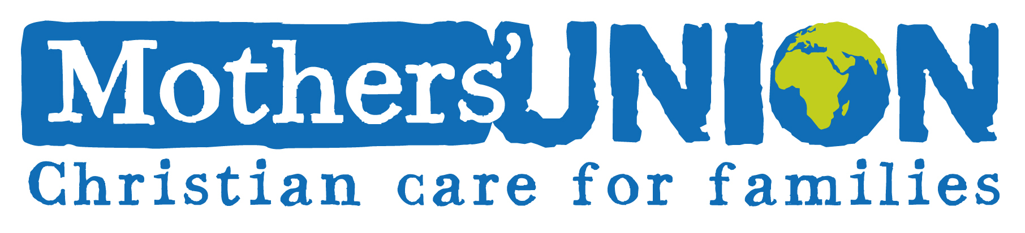
GIFT AID

I have paid my subscription to the branch named below, and wish the Mothers’ Union Hereford Diocese (Registered Charity Number: 249674) to reclaim the tax on the payment made.

I confirm that I have paid or will pay Income Tax and / or Capital Gains Tax for each tax year
(6 April to 5 April) that is at least equal to the amount of tax that ALL the charities I donate to will reclaim on my gifts for that tax year. I understand the charity will reclaim 25p of tax for every £1
I give them.

Name
Address
Postcode | (if we don’t have your postcode, we cannot claim the Gift Aid!)
Branch
Signature
Date

GIFT AID

I have paid my subscription to the branch named below, and wish the Mothers’ Union Hereford Diocese (Registered Charity Number: 249674) to reclaim the tax on the payment made.

I confirm that I have paid or will pay Income Tax and / or Capital Gains Tax for each tax year
(6 April to 5 April) that is at least equal to the amount of tax that ALL the charities I donate to will reclaim on my gifts for that tax year. I understand the charity will reclaim 25p of tax for every £1
I give them.

Name
Address
Postcode | (if we don’t have your postcode, we cannot claim the Gift Aid!)
Branch
Signature
Date

