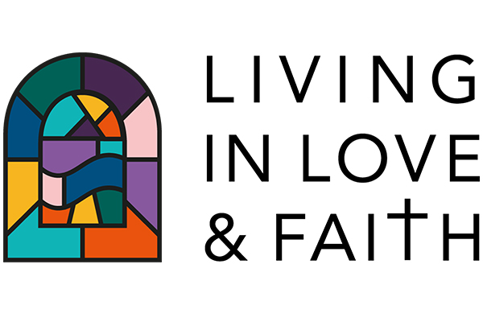
THE LLF NEXT STEPS GROUP:
DRAFT timeframe for engagement, discernment and decision-making
This document sets out a timeframe for church-wide engagement and for episcopal and synodical involvement in discernment and decision-making. This timetable assumes that the church-wide engagement period ends in November 2021 but this period may be extended into early 2022. Given the unpredictability of the covid pandemic, it may be necessary to consider prolonging the engagement period and to note how this would affect the decision-making timetable.
Proposed timetable
Time Activity
Jan – Feb 2021 Appoint LLF Advocates and establish Reference Group
Feb – Nov 2021 - Church-wide engagement Designing, gathering, analysing and summarising feedback
- Episcopal listening and reflection
- Ecclesiological theological work and interaction with church-wide findings
Jul 2021 General Synod engagement with the LLF resources / course
Sep 2021 - College of Bishops: Reflecting on and engaging with initial findings from engagement
- Discussion of ecclesiological work and findings
Dec 2021 House of Bishops: Reflections on findings from church-wide engagement and ecclesiological work
Jan 2022 College of Bishops: Reflections on the findings and possible implications
Feb 2022 (New) General Synod: initial engagement with findings
May 2022 House of Bishops: discernment & implications for decision-making
Jul 2022 General Synod: further engagement with the findings and with the House of Bishops’ initial reflections
Nov 2022 General Synod: consider recommendations from the House of Bishops

