Diocesan
User guide

Portal and Database
(CMS)

Contents

Registering For an Account
Searching For a Contact
Searching For a Post

Registering For an account

Before you can use the Portal or Database you will need to register for an account. It is best to do this as soon as possible because you will need to be manually accepted by the Diocesan Office.

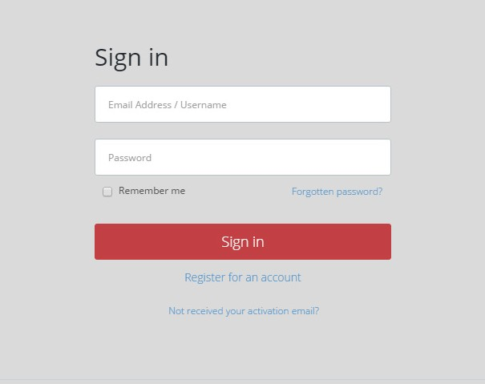
First, go to cofeportal.org (this is the address you will go to each time you access the database). The first time you visit you will be taken to the login screen. Click ‘Register for an account’.

On the next screen enter your name, your email address and a password in the relevant boxes, and then click register.

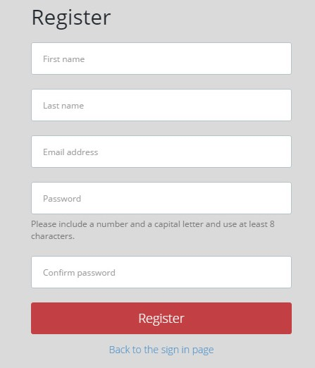

You will now receive an email with the subject ‘Church of England: Complete Registration’. In the email click the ‘Activate your account’ link.

You are now registered on the CofE Portal. Click ‘Sign in to the Portal’ and sign in using the email address and password you entered when signing up.

Once you are signed in you will be on your Portal Dashboard, Your Dashboard may or may not be populated but you change this by clicking ‘manage your panels’.

You can now select which panels you would like to add to your dashboard. You will need to add the ‘Content Management System’ panel by clicking the off/on switch on the right hand side, but feel free to add any others that you wish, and then click ‘Close’.
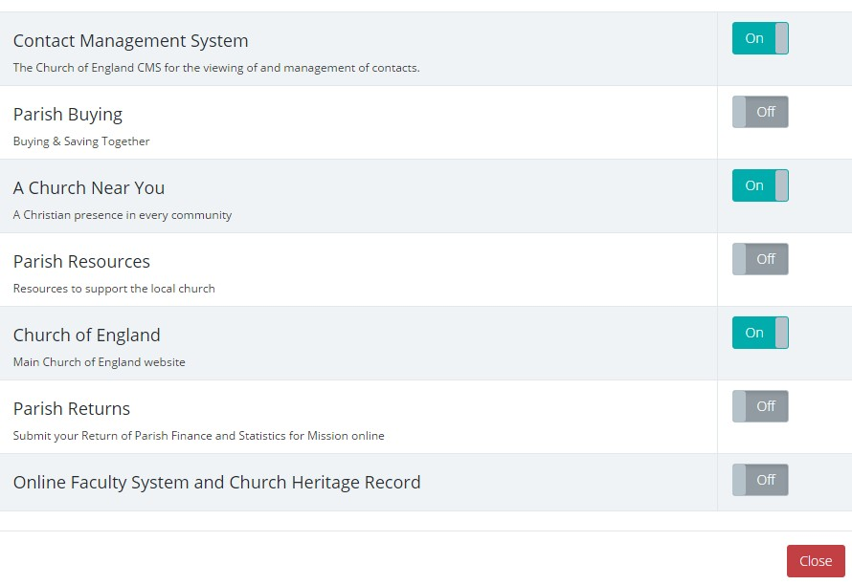

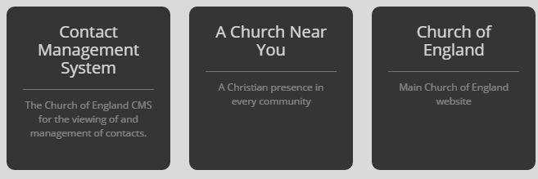
Now that you’ve added your panels, click the ‘Content Management System’ panel. (This is our database)

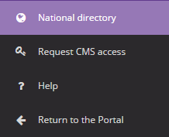
You will automatically have access to the National Database, but only limited information will be available due to Data Protection from various Dioceses, in order to have full access you will need to request this from the appropriate Diocese. To gain full access to our database, click the ‘Request CMS Access’ option on the menu on the left.

On the following page fill in the options as in the image below and then click ‘Request access’.
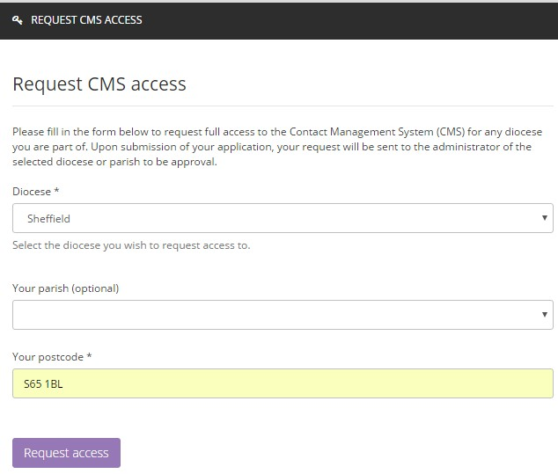
Hereford

This alerts me by email that you have requested access and, I will then accept your request.

Once your access has been confirmed you will then be able to log in at cofeportal.org and access the full database.
If your requesting access for other Diocese use the drop down box and select the Diocese you want
Searching For a Contact

If you know the name (or other details) of the person you want the find, you should use the
‘Contact search’ option, otherwise try the ‘Post search’.

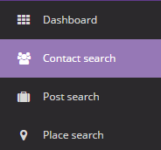
To start, click ‘Contact search’ on the menu bar on the left of the screen.

You will now be presented with various search options.

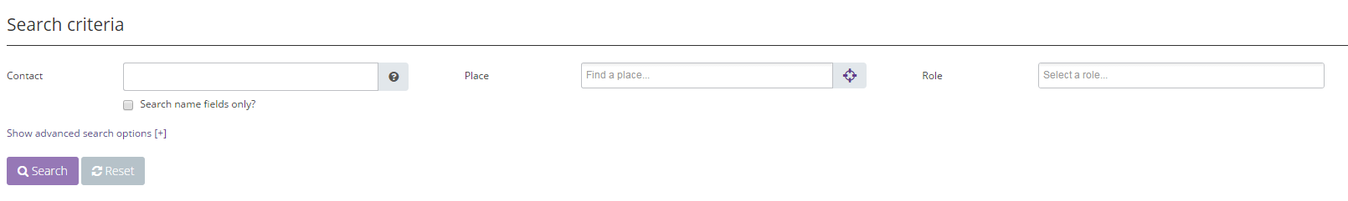

In the ‘Contact’ field you can search for any information relating to the person you are searching for (rather than their post or parish). This can include first name, surname, address and email. If you get too many results you can narrow this down further by ticking “Search name fields only”.

IMPORTANT NOTE: if you put more than one word in the ‘Contact’ field, you should use the word “AND” (in block capitals) between words, otherwise it will search for anyone whose record contains ANY of the individual words. For example Kerry AND Preedy will only bring up and anyone who is called Kerry Preedy, but without the AND it brings up any record that contains the words Kerry or Preedy

If you are getting too many results you can also specify the ‘Place’ and ‘Role’, if you know it. Searching for a ‘Place’ will search everywhere that comes under that place, for example, searching “Hereford Archdeaconry” will also search every Deanery/Benefice/Parish/Church contained within the Archdeaconry). If you know the role the person holds then you can enter this in the “search a role section” It helps to keep the number of returned suggestions down.

You will then have a list of all contacts matching your search criteria, once you have located the appropriate record, click the ‘Open contact’ button on the right hand side.
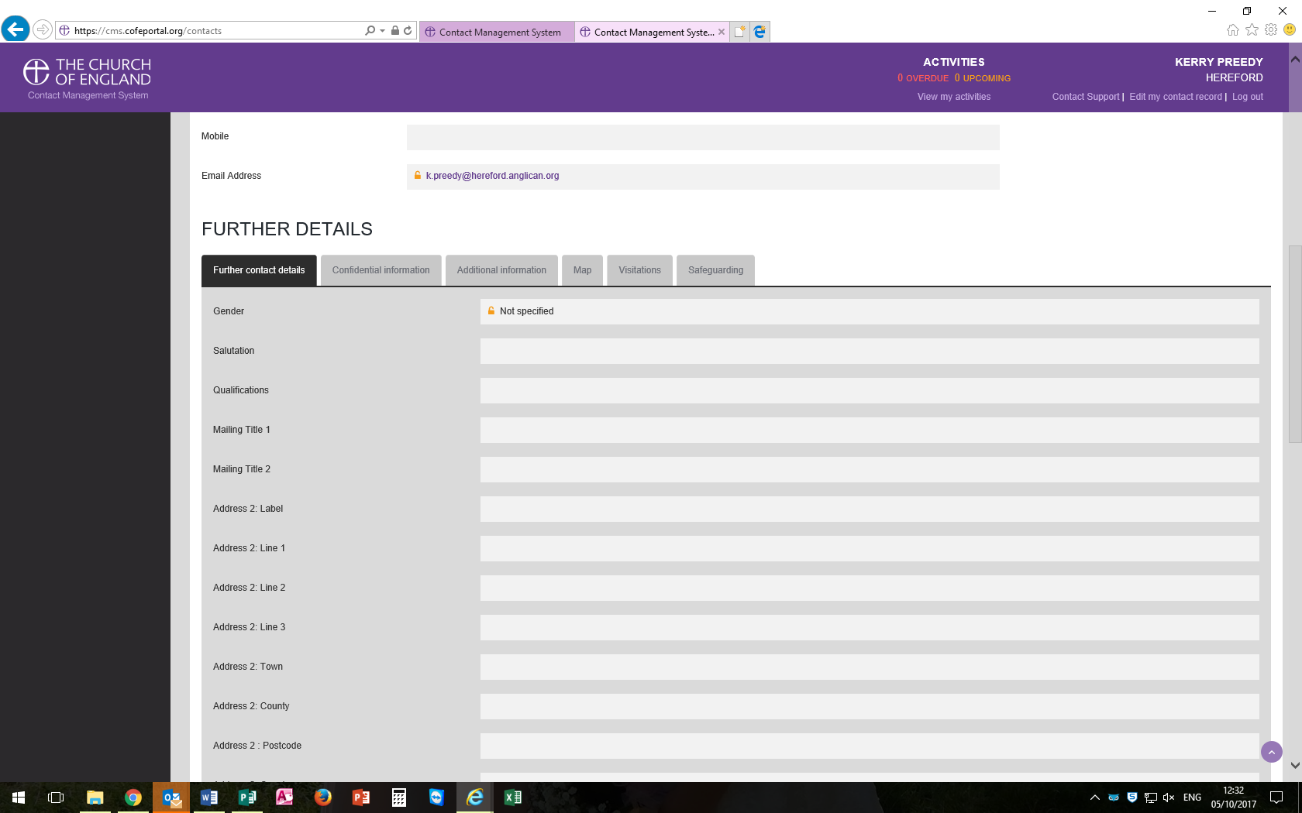
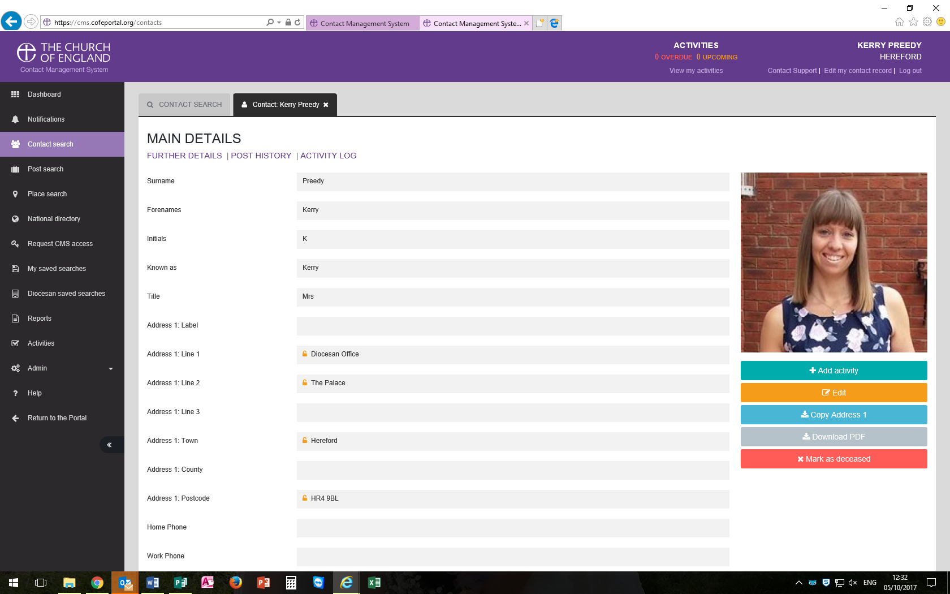
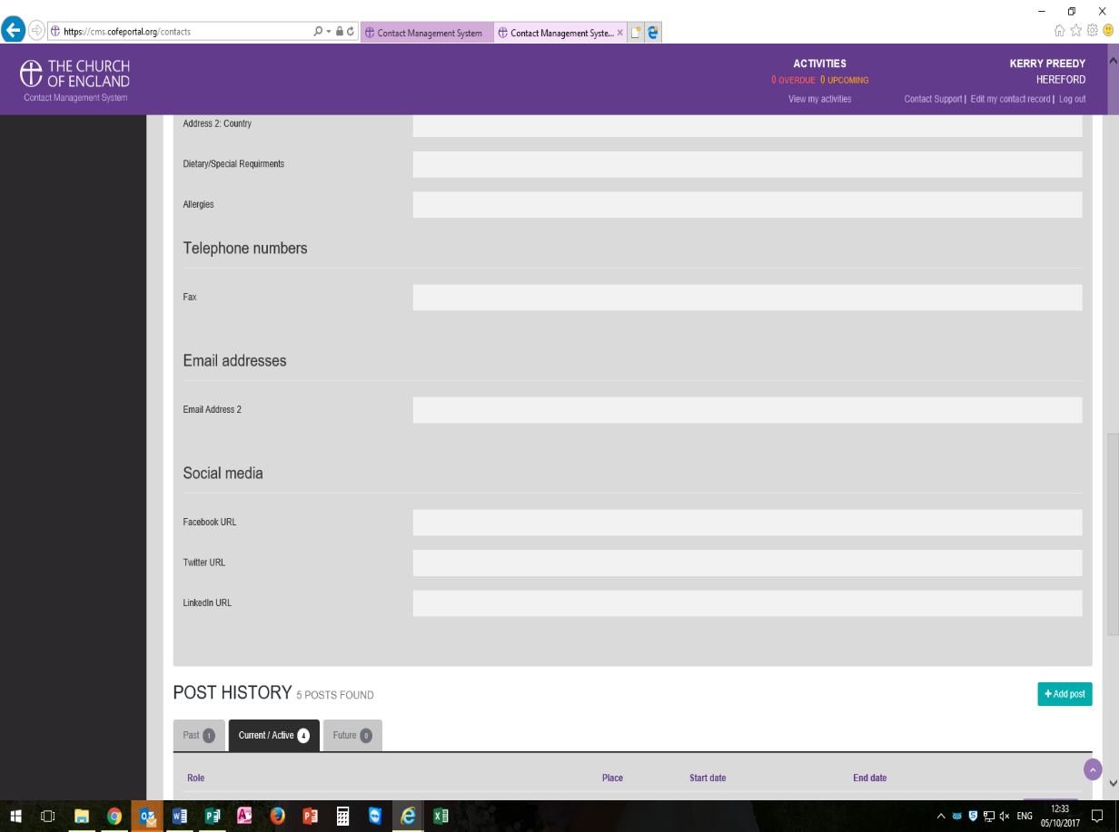
This then brings up all the contact details held for that person. You can scroll down the right hand side of the page.

You can click on the email address to send them an email. A warning will pop up asking if you want to use your email account to connect to this person that’s fine.

The further details section is where you will find information such as if they have an allergy or dietary requirement, possibly even a second address to contact them on

The Post History shows you all their jobs, past current and future

Searching For a Post

If you don’t know who you want the find but you know the role you want to find, you should use the ‘Post search’ option.

To start, click ‘Post search’ on the menu on the left of the screen.

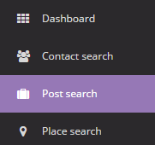

You will now be presented with various search options.

In the ‘Role’ field, select the role you want to find, you can then also narrow this down by selecting an area in the ‘Place’ field. Searching for a ‘Place’ will also search everywhere that comes under that place, for example, searching “Hereford Archdeaconry” will also search every Deanery/Benefice/Parish/Church contained within the Archdeaconry. If you are searching for a Parish or Church you can also tick the ‘Include posts from parent places up to Benefice’ tick-box if the post you are looking for isn’t showing -This works well when looking for Clergy if you don’t know their exact job title i.e. Stipendiary, SSM etc.

If you want all roles to appear for an area/place then leave the role section blank.

The ‘Post date period’ option should be left as ‘Present’ unless you are searching for someone who isn’t currently in post.

Once you have found the post you are searching for you can choose one of three options.

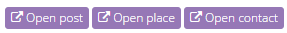

To see information about the person (address, phone number, etc.), click ‘Open contact’, to see information about the post (start date, end date or comments about the role), click ‘Open post’, or to see information about the area (reference numbers, patron, etc.), click ‘Open place’.

If you have any queries please contact
Kerry Preedy, Office Manager on 01432 373300 or
By email k.preedy@hereford.anglican.org

